**Data preparations in Data Science**

I.

1. Create 2- One dimensional Arrays and print sum of individual element and multiply each with 3

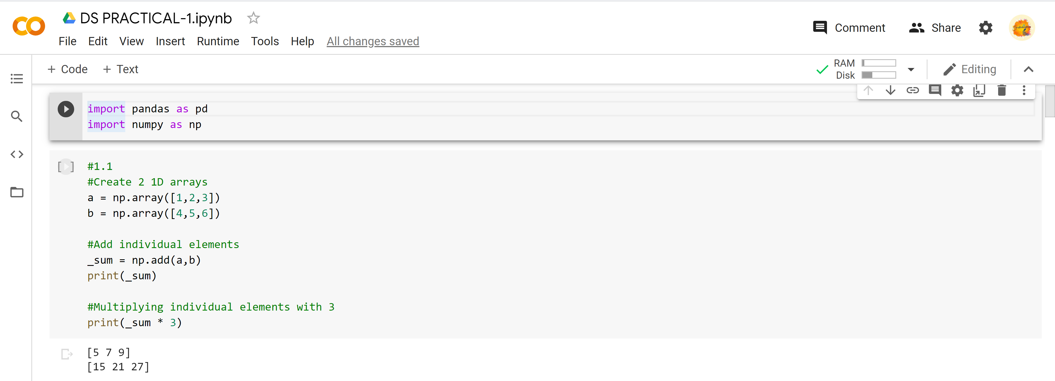

1. Manipulate Logical and, OR Not operations on Array

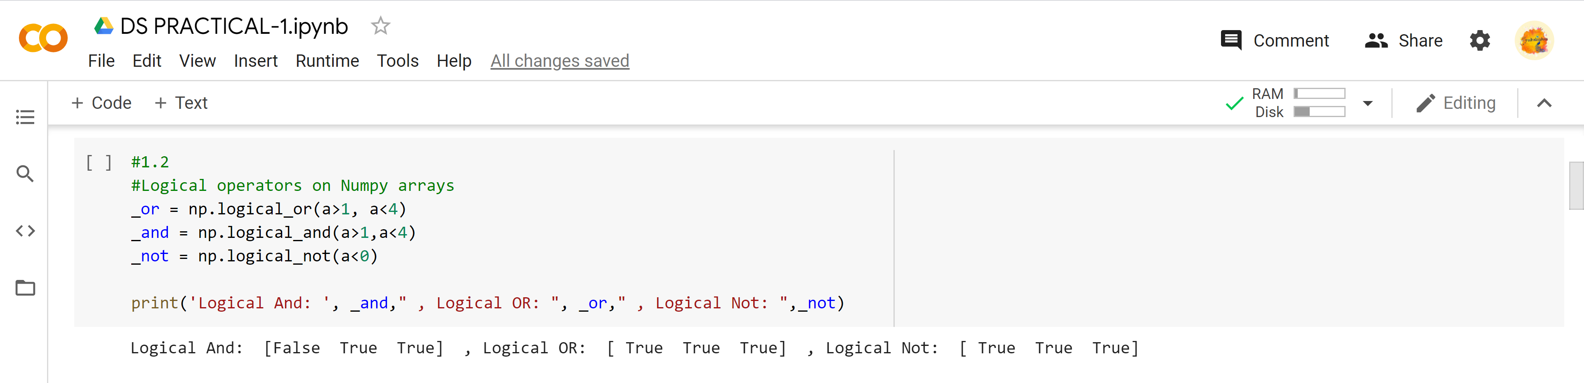

1. Perform data Slicing Operations

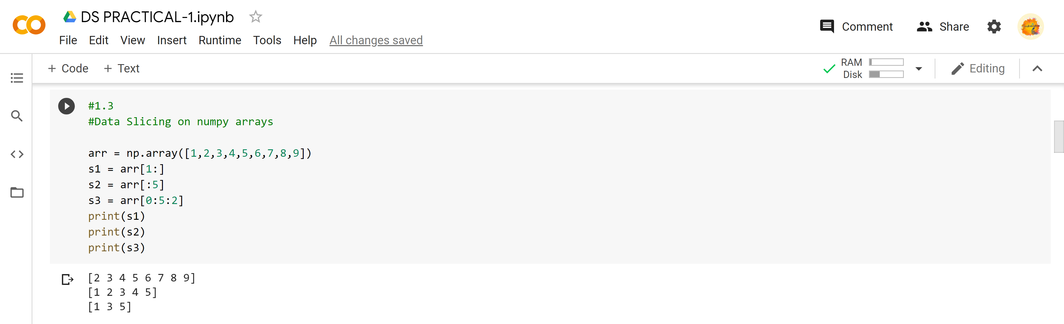

1. Perform Boolean operations between arrays

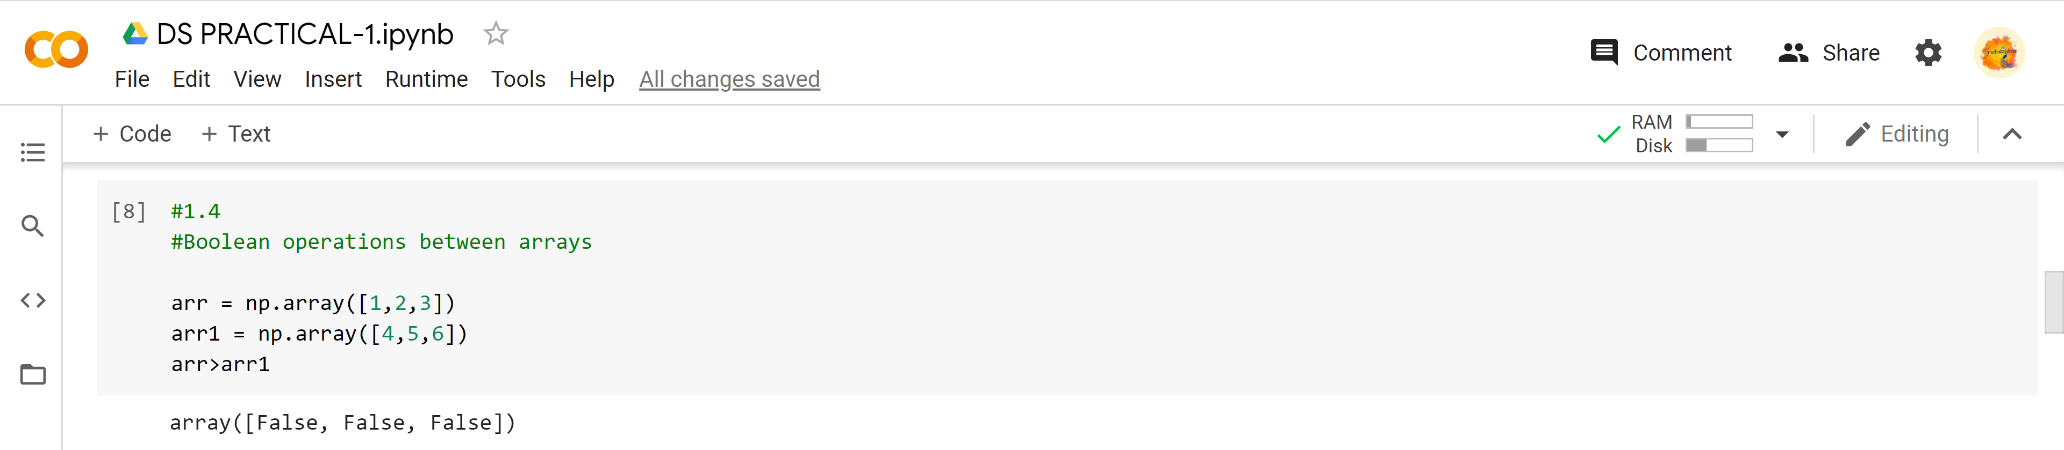

II. Create 2- Two dimensional Arrays and print sum of individual element and multiply each with 3

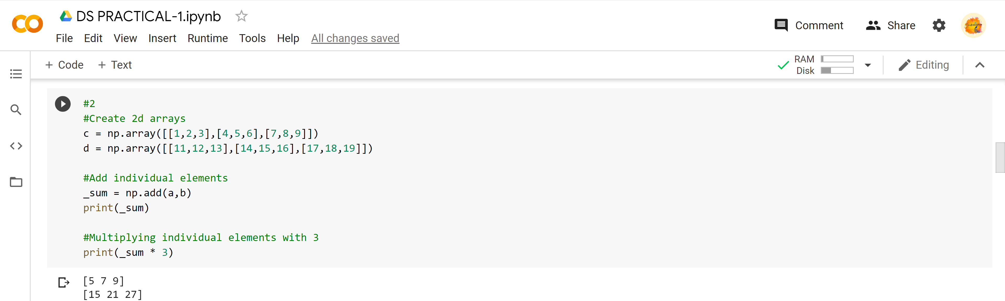

1. Manipulate Logical and, OR Not operations on Array

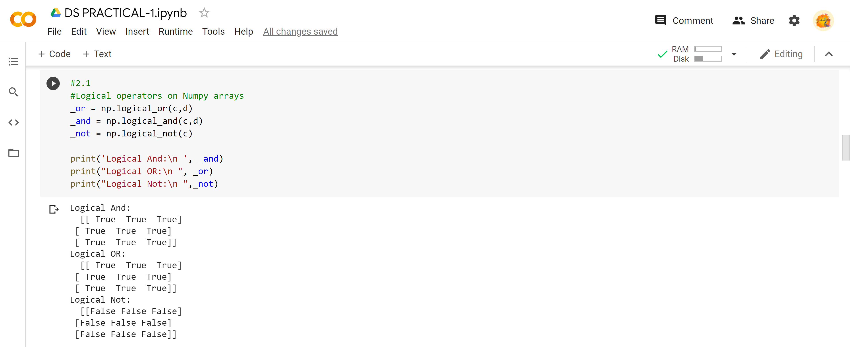

1. Perform data Slicing Operations

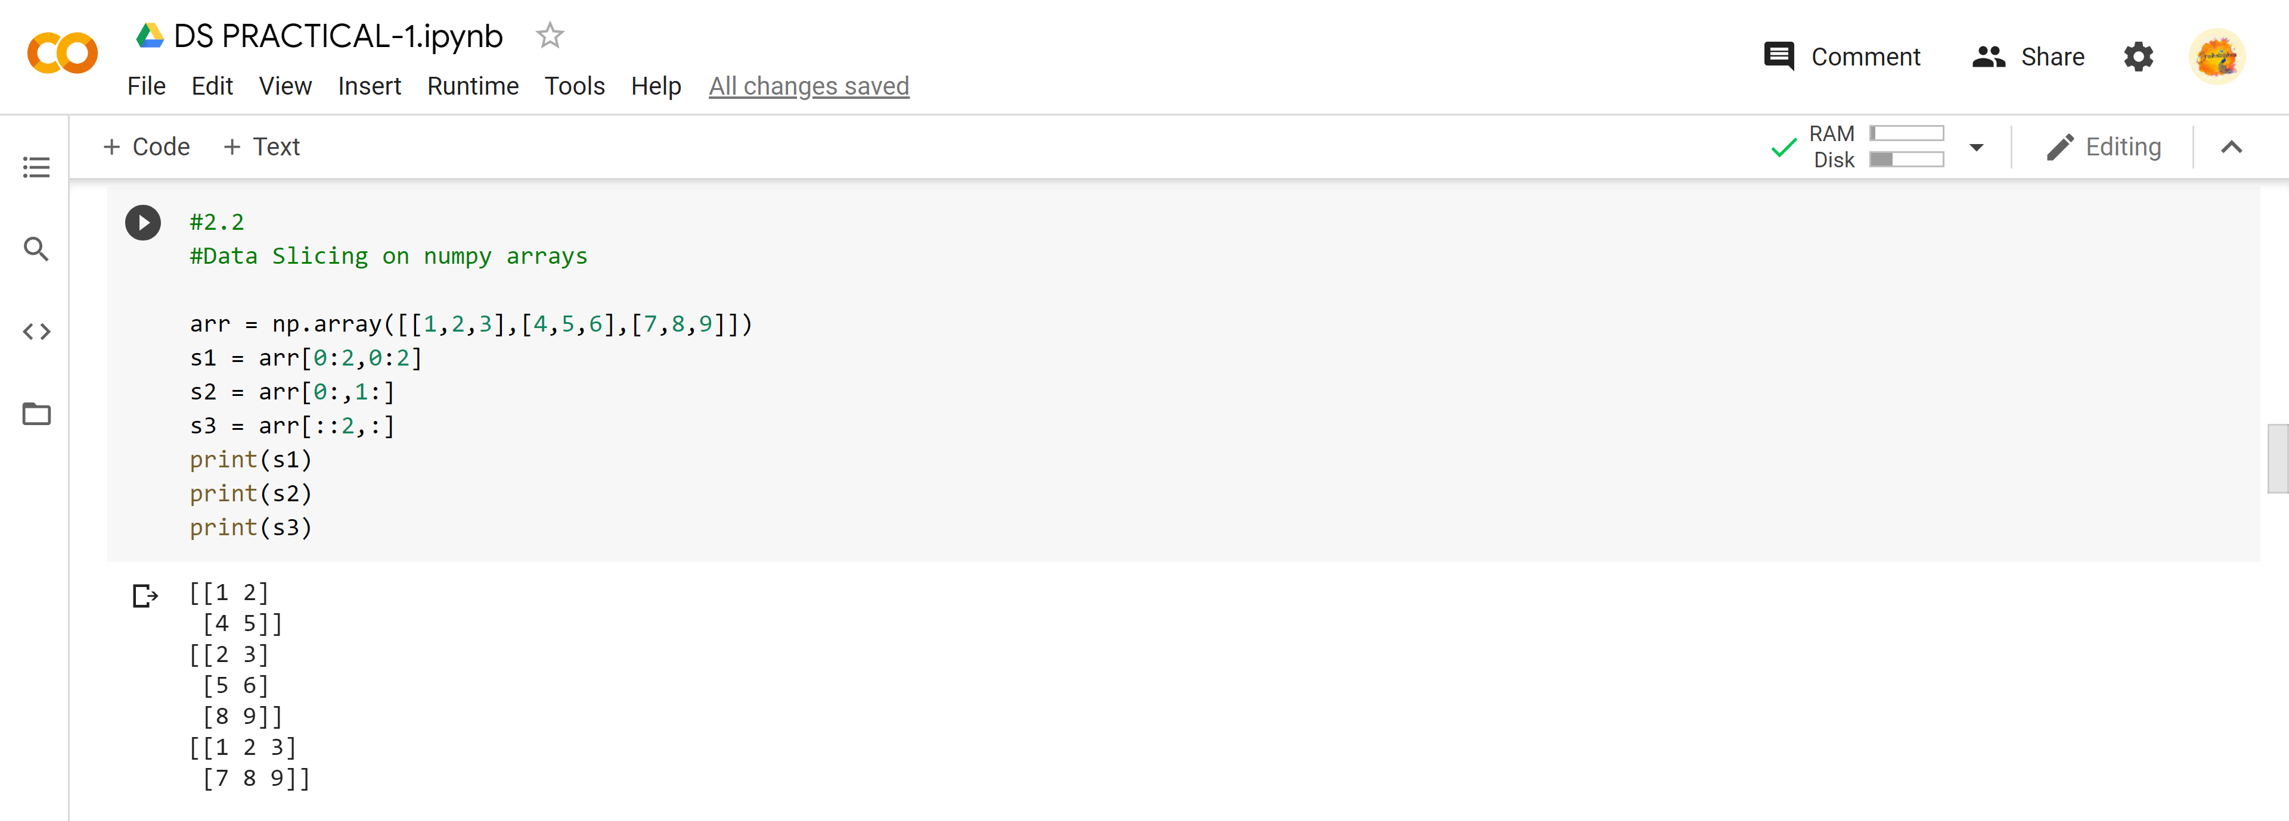

1. Perform Boolean operations between arrays

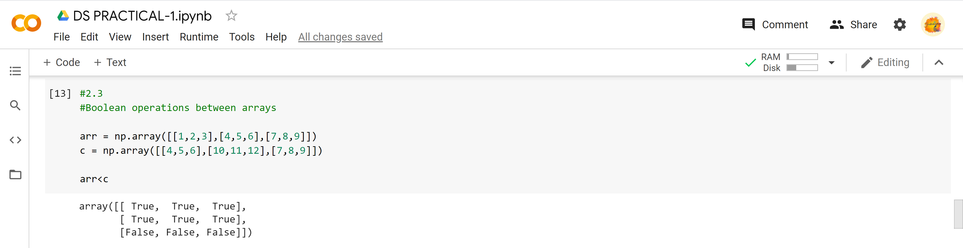

III. reshape(), arrange(), resize(), hsplit(),Extract ones, Two’s in arrays, Scalar()

reshape()

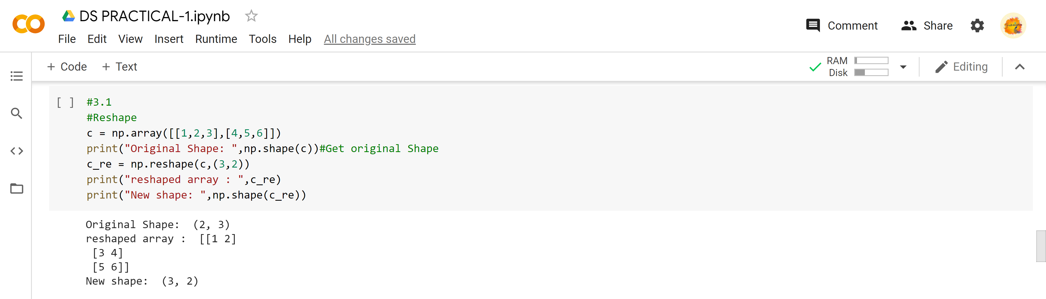

arrange()

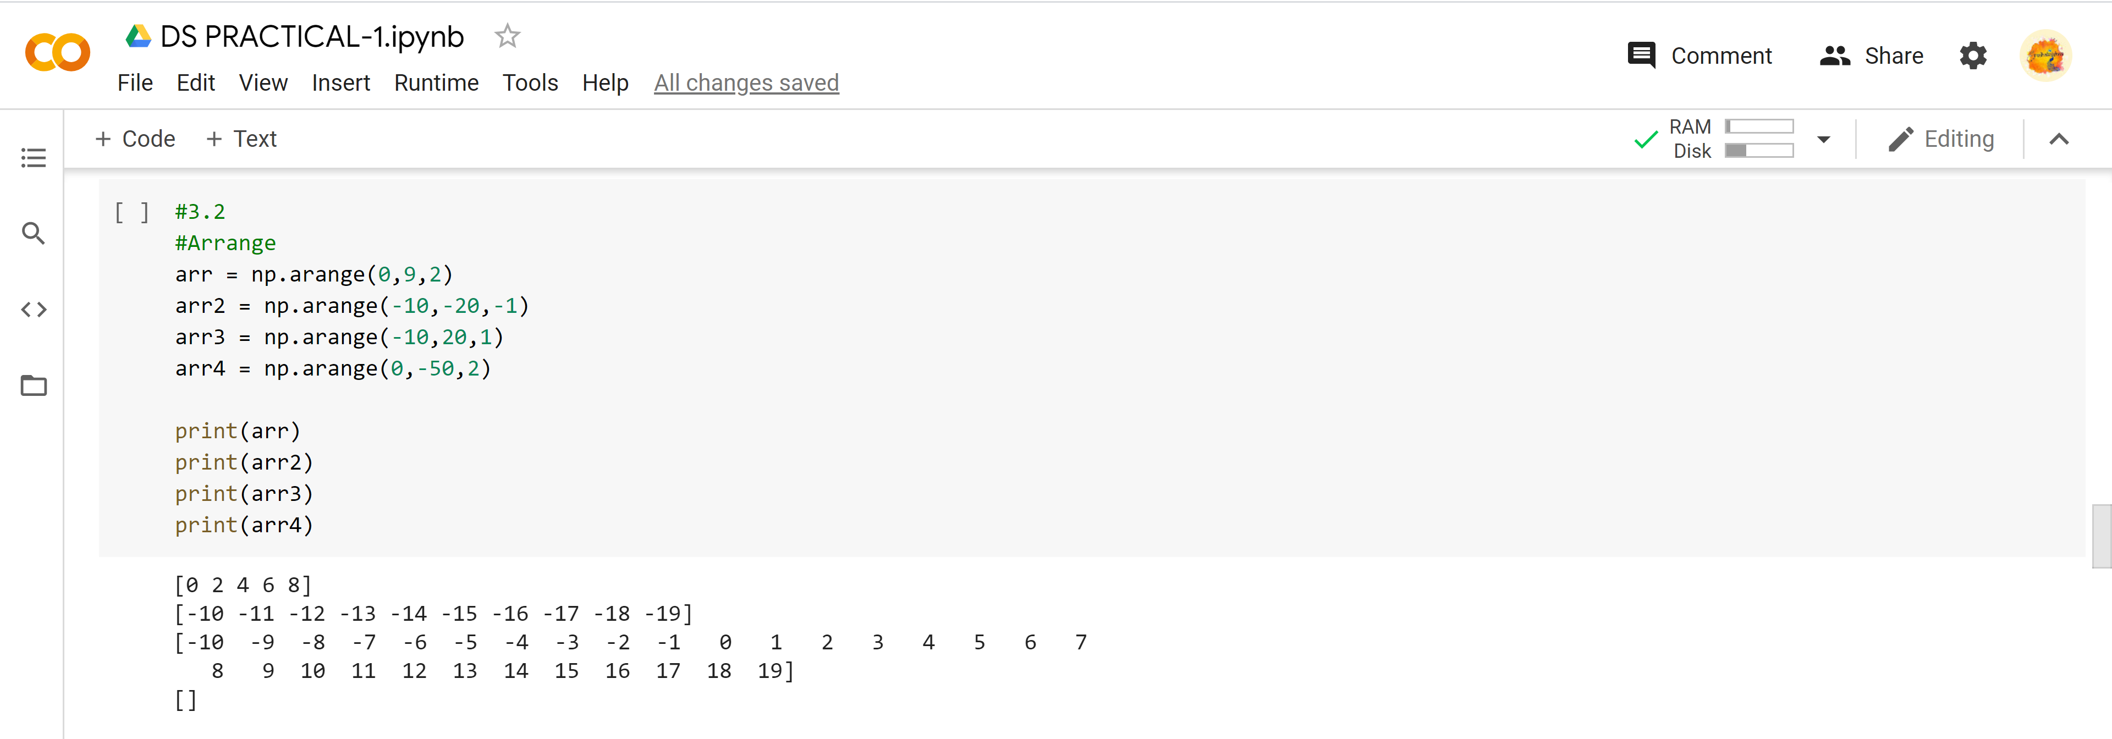

resize()

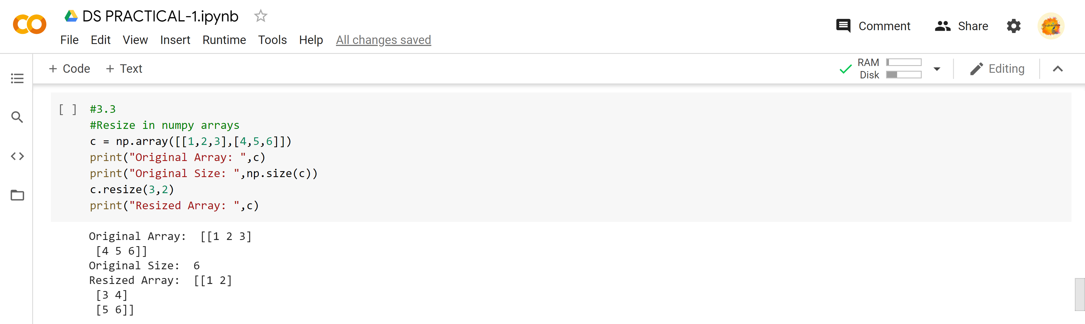

hsplit()

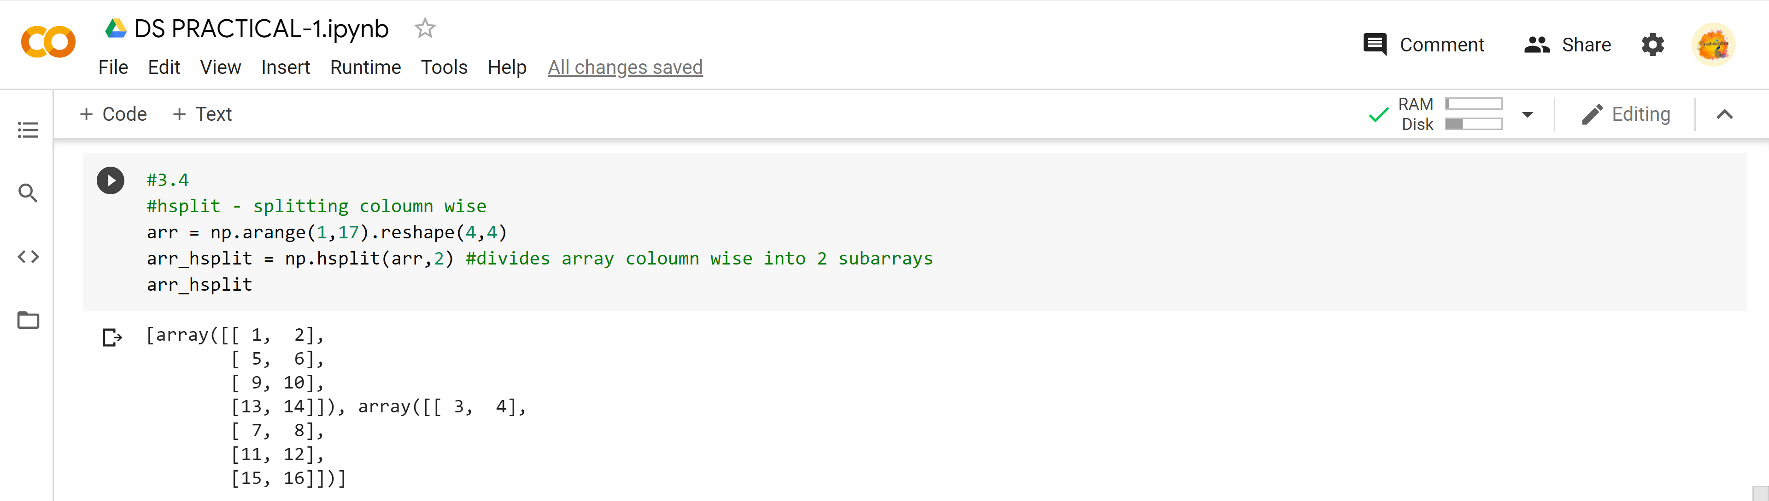

Extract ones, Two’s in arrays

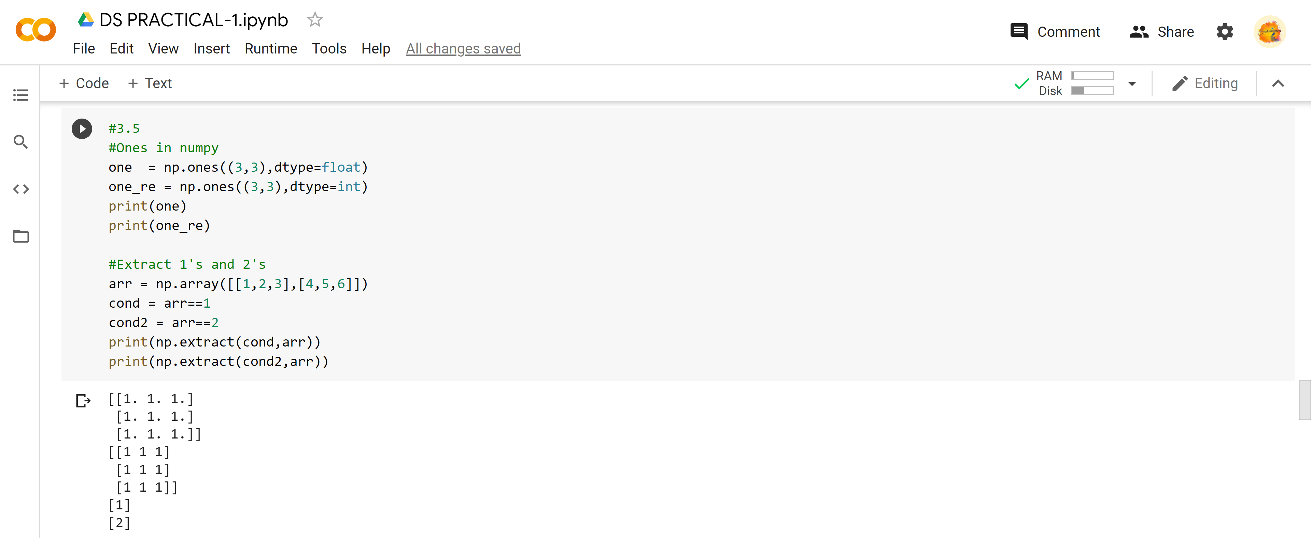

Scalar()

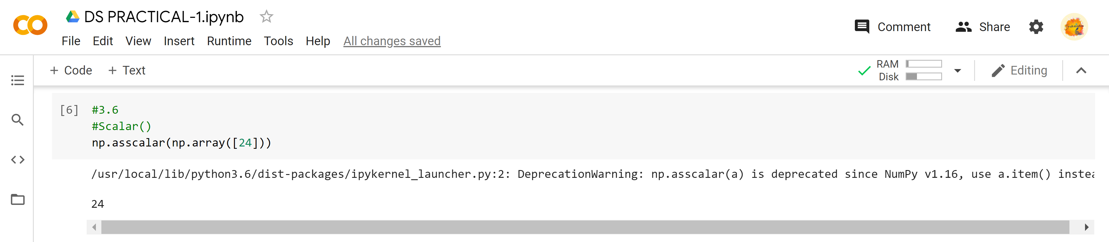

IV. Create Data Frame with a MultiIndex

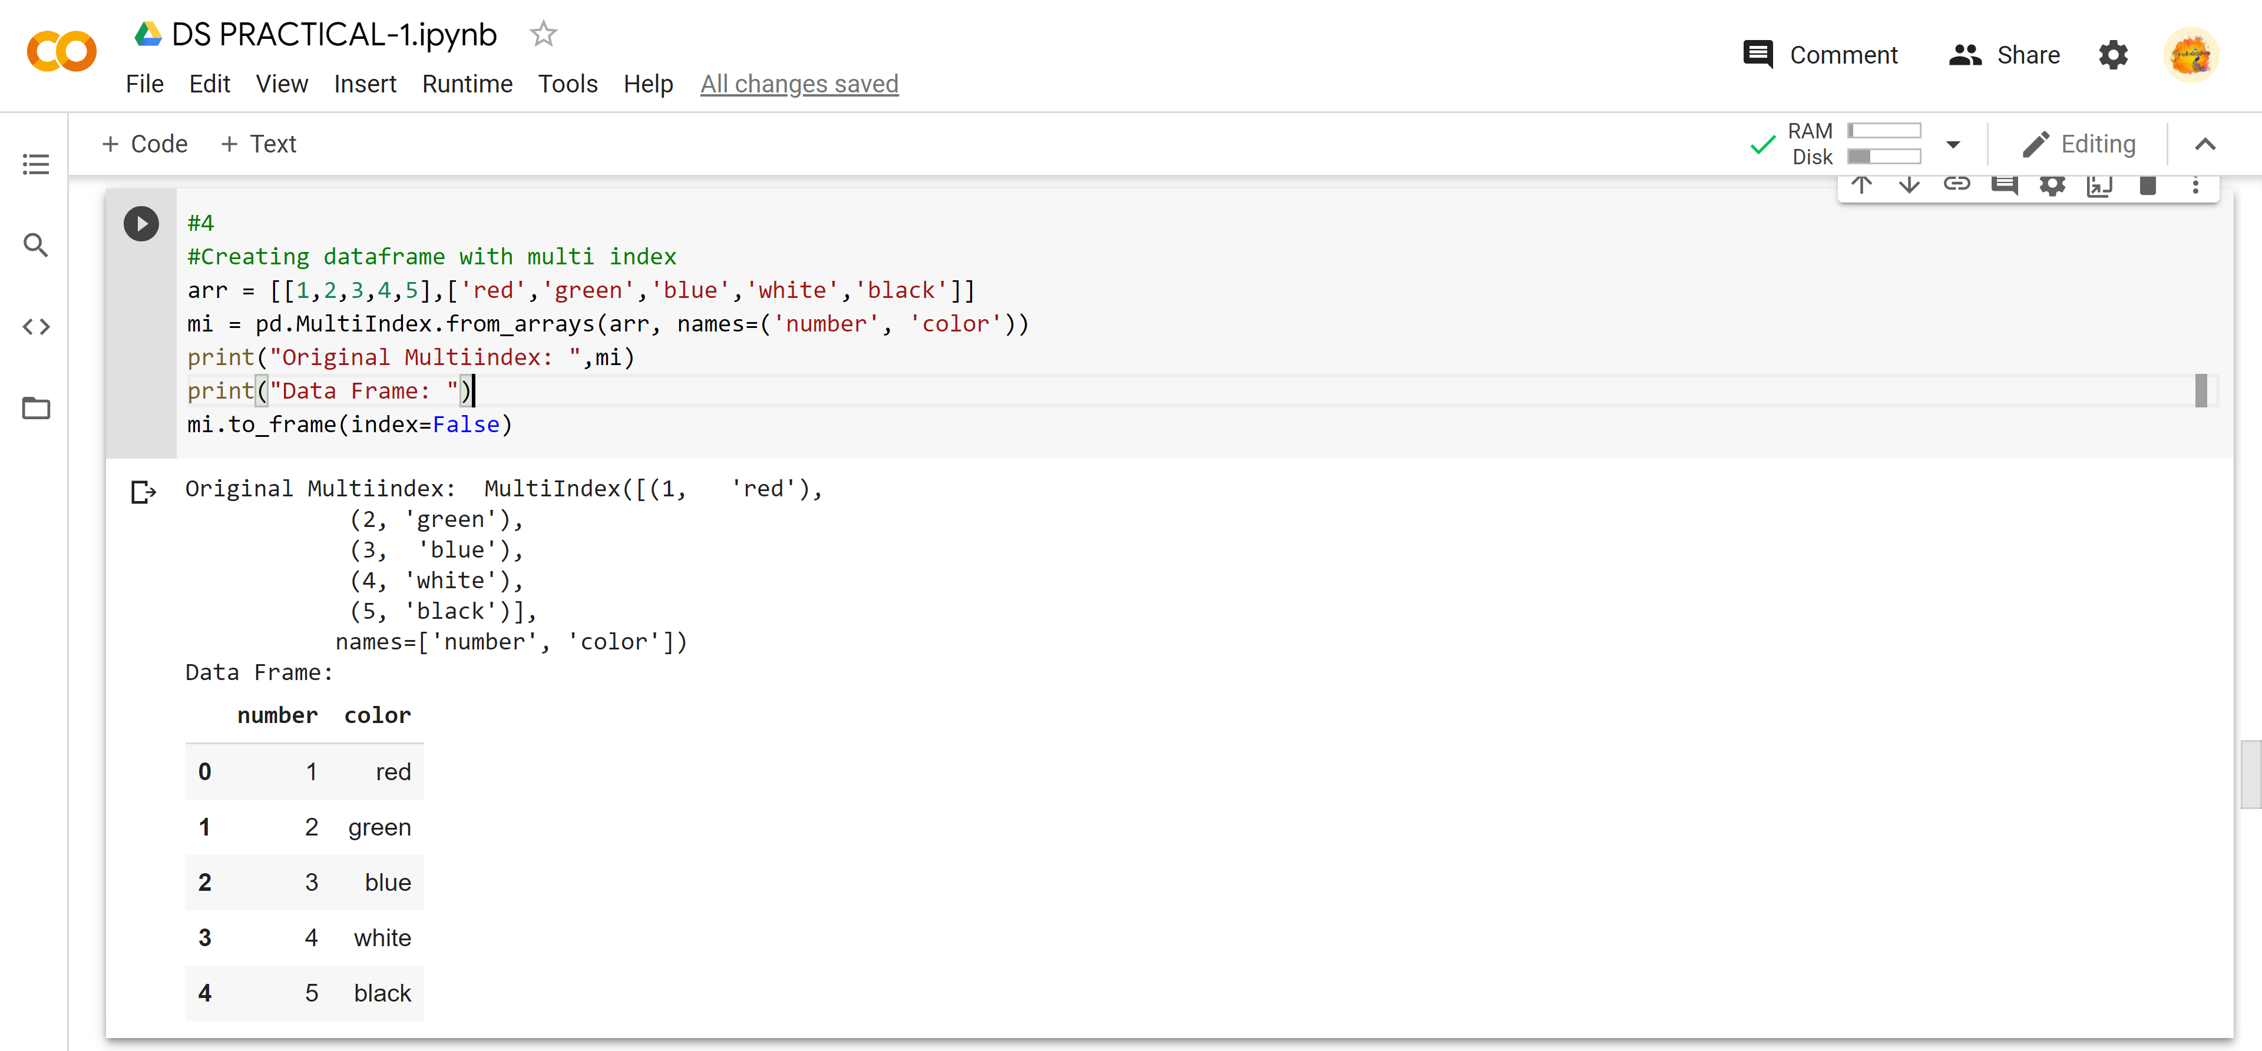

V. import .CSV file do the following

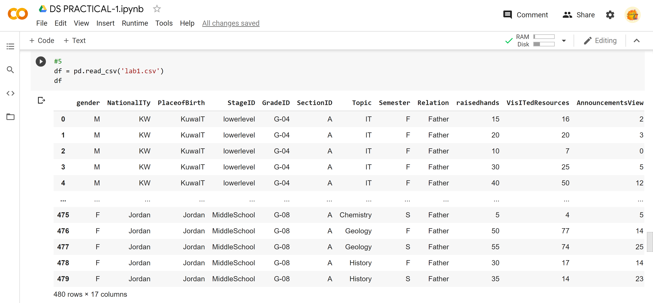

(https://www.kaggle.com/aljarah/xAPI-Edu-Data- [Students' Academic Performance Dataset](https://www.kaggle.com/aljarah/xAPI-Edu-Data))

1.describe()

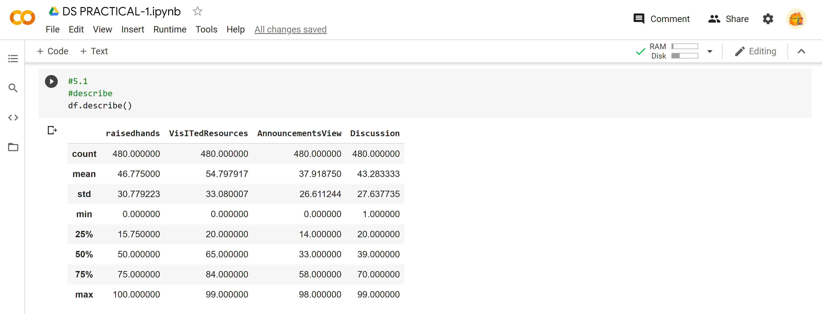

2. Mean()

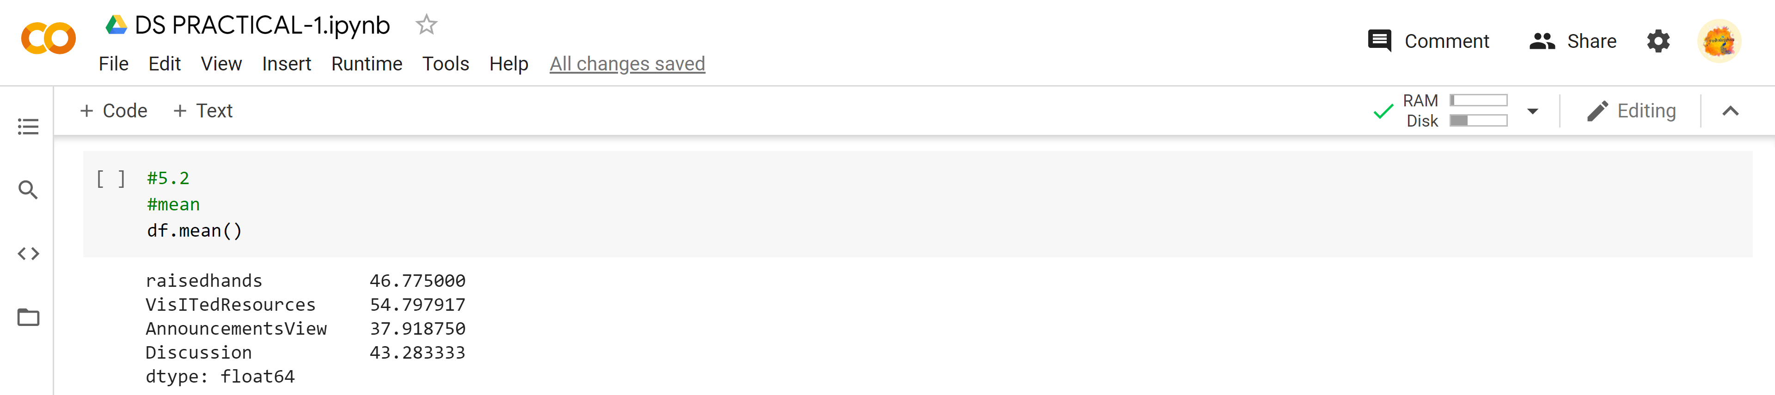

3. Median()

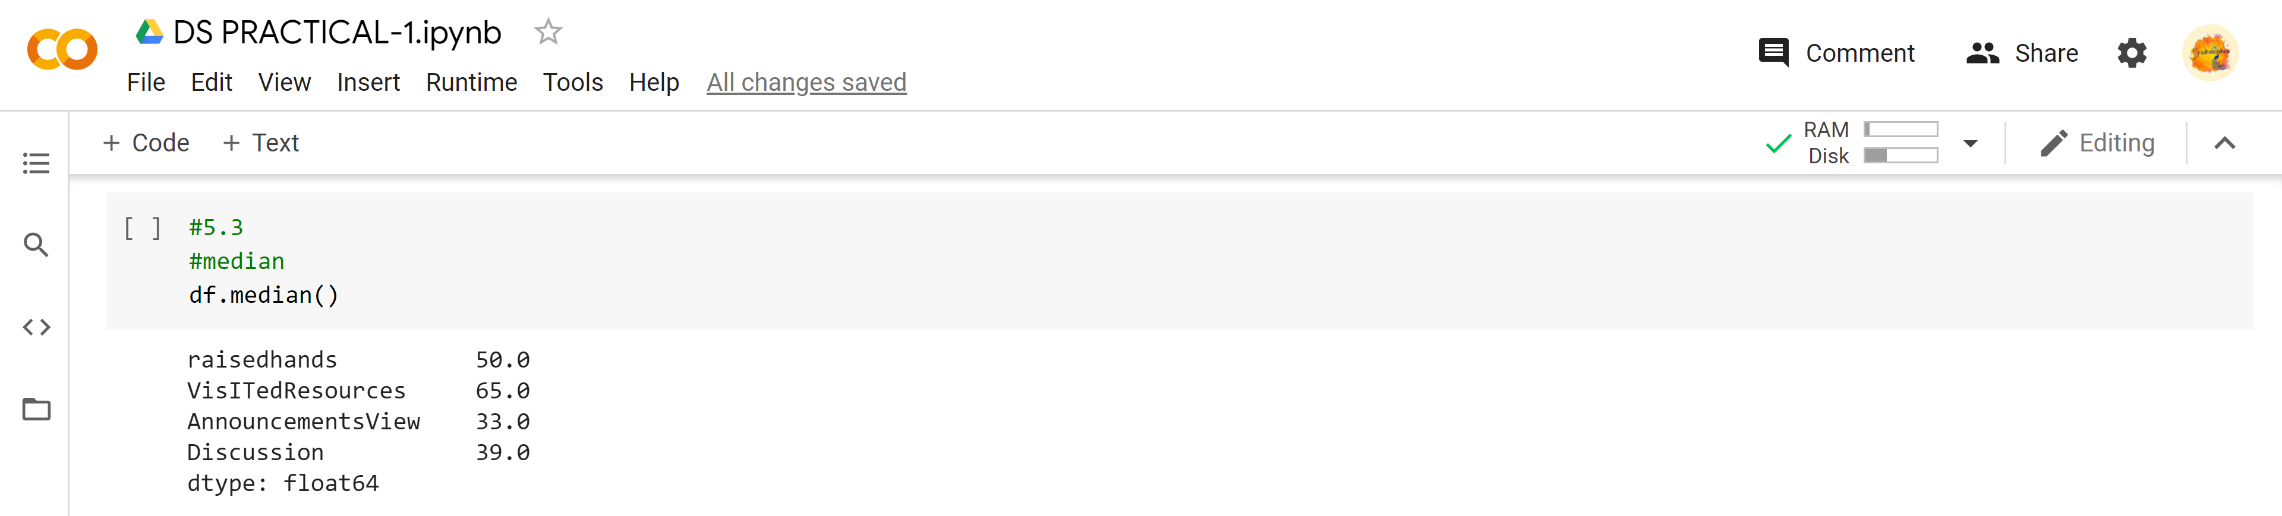

4. Slicing operations

